**Omics Database Generator**

**Manual**

Joseph Guhlin

Contents

How do I get help? 2

**1 Introduction** 3

Dependencies 4

Structure of the Software 4

All Modes 5

Java 5

Query Server & Database 5

Web Browser 5

Database Generation 5

InterProScan 5

NCBI BLAST+ 5

HMMER 5

File Formats 6

Assembly Files (FASTA, GFF3) 6

Gene Definitions (GFF3, GTF) 6

Protein Sequences (FASTA) 6

Getting Started 7

Global Metadata Files 9

Gene Ontology 9

ENZYME 9

UNIPATHWAY 9

Molecular Interactions 9

Pre-Configuration Processing 9

Running InterProScan 10

Configuring the Database 10

Post-Configuration Steps 12

Generating BLAST+ Scripts 12

Generating the Database 13

Querying the Database 13

Web-based Query Mode 13

Command-line Query Mode 13

query-tassel 14

query-gene-list 14

annotate-gene-list 14

coexpression-network 14

get-biological-processes 14

get-biological-processes-all-genes 14

Internal Data Structure 15

Nodes 15

Relationships 15

Examining the Internal Data Structure 15

Language Hooks 15

R-language 16

Python 16

Java 16

Perl 16

Additional Language Hooks 16

## How do I get help?

If you’ve read through the manual and still need assistance, please check the FAQ found on github:

<https://github.com/jguhlin/odg>

If you continue having trouble, you may email the developer at [joseph.guhlin@gmail.com](mailto:joseph.guhlin@gmail.com) with details of what issues you are experiencing and how you have tried to resolve it.

# Introduction

This software takes genomic data, including sequence data, gene definitions, annotations, expression, and other data to compile a queryable graph-theory based database for intra- and interspecies comparisons. Primarily analysis is completed by using established tools and common assumptions to process the output of those programs. Custom data can also be entered into the database for advanced queries.

Queries can be completed by command-line, a provided web interface, or programmatically either through an API or directly to the database.

Any genomes that have data available in standard file formats are compatible with this software, not just plant and bacteria genomes.

## Need for this Pipeline

With a rapid expansion of genomic resources, researchers need the ability to rapidly compare genomes and putative coding regions to existing, annotated, curated genomes and datasets to derive maximum information.

Genomic resources are increasing at an accelerated rate. Just as well, existing genomic resources are being updated with new assemblies and new annotations. Assemblies and annotations can differ widely between releases due to new software releases, additional sequencing, and new information regarding genetic data. Existing material may refer to an older annotation or assembly and becomes difficult to use with newer releases unless additional data mining is performed. This pipeline automates many of these steps and returns the data in a comprehensive database.

Genomic comparisons are also incredibly useful in this time of accelerated data expansion. This pipeline automates protein blast searches for homology in the same species and between species, with a focus on comparisons between other species in the search for statistically significant orthologs.

Genomic context is important for helping to validate GWAS candidates before performing additional labwork. Genomic context is also important in comparisons between species as well as deriving an additional understanding of a genome. This pipeline automates the importation of Gene Ontology (GO) terms and Plant Ontology (PO) terms. The importation of Interproscan results is also handled and extrapolated to link the gene models to the GO terms as appropriate. Terms for Plant Ontology are imported if a TAIR style file is provided. Expression data from Cufflinks output is also imported and interpreted using Pearson correlation looking for both positive and negative correlation and tissue or experimental condition specificity.

Additionally, flanking sequence tagged data is mapped onto the assemblies, and Affymetrix probe sets are mapped to the mRNA models. This allows rapid remapping when a new assembly is released.

This allows searches via gene model s or chromosome and base pair location numbers (in the form of Chr:Loc such as Chr2:340812 or 2:543923), and returns the nearest genes, and if there is enrichment of GO terms or PO terms, and if there is enrichment of GO/PO terms in orthologous regions of other species. Enrichment for tissue specificity or experimental condition specificity is also provided if the data is available. Mutants and Affymetrix probeset data are also returned if in the nearby genomic neighborhood.

## What this Pipeline is Not

This pipeline does not, at this time, do any gene prediction. The pipeline takes in the GFF files provided from either annotation sources or gene prediction software. ODG provides an additional layer of annotation on top of the gene predictions from software, and could be used to provide some easy, comparative-based annotations.

## Brief Overview of Data from this Pipeline

This pipeline combines several different types of data, as well as additional analysis of this data, into a unified database. This allows some unique queries that would be difficult or impossible with only the raw files. Some examples include:

* Translate Gene IDs from one annotation to another annotation
* Orthologs between species, including Blast Score Ratios (BSR)
* Genomic neighborhoods(a location on a chromosome and all nearby genes), including data such as
  + Expression enrichment for genomic neighborhoods
  + Gene Ontology / Plant Ontology term enrichment for genomic neighborhoods
  + Families and Domains via Interproscan enrichment for genomic neighborhoods
  + Similar neighborhoods in species and out species
* Neighborhoods can also be created by co-expression and negatively correlated genes, as well as orthologs
* Possible locations of Transposon-mediated mutant insertions
* Possible miRNA locations
* Ontology queries for genes and regions
* Syntenic regions based on gene models and blast searches
  + Can be used as additional evidence for Gene ID translations between annotation versions
  + Can be used with protein blast results between species as well

# Dependencies

## Structure of the Software

ODG has both a “query server” which is designed to be utilized on local machines, and a “database generation mode” which is designed to be used on a more powerful computer. Many of the analyses which inform ODG must also be run on more powerful machines.

## All Modes

### Java

Java is required for ODG, for both the query server and database generation. Java should be pre-installed on most machines, but the latest version is also available for download here: <https://www.java.com/en/download/>

ODG requires version 1.8 at this time.

## Query Server & Database

### Web Browser

Interacting with the query server and configuration server is often done from a web browser. ODG recommends Google Chrome browser, although Firefox or any standards-compliant browser will often work: <https://www.google.com/chrome/browser/>

## Database Generation

For those at a research-based institution, it is advised that you check with staff to identify any software already installed.

#### InterProScan

InterProScan provides many useful dimensions of data for genomes in ODG. It, and instructions for installation of it, are provided here:

<https://github.com/ebi-pf-team/interproscan/wiki/HowToDownload>

<https://www.ebi.ac.uk/interpro/download.html>

#### NCBI BLAST+

NCBI BLAST+ is often found on many scientific and research-based computing systems, however it can be downloaded here: <https://blast.ncbi.nlm.nih.gov/Blast.cgi?PAGE_TYPE=BlastDocs&DOC_TYPE=Download>

#### HMMER

HMMER is used to identify HMM sequences in genome or protein files. While no specific uses with ODG are provided, output from HMMER is supported. If you need HMMER you may download it from this location: <http://hmmer.org/download.html>

# File Formats

ODG takes files used in bioinformatics, and builds a connected database of all the files. In order for this to function properly, each file must reference items in the other file properly. Here are the most common and which fields are used to connect. Many times, you can reformat a file with the Find/Replace function in most text editors. *Nano* is recommended on Mac OS X and Linux, while *Notepad2* (free software, available online) is recommended on Windows.

Here we will briefly discuss the most problematic file formats and provide some remedies on how to repair them.

## Assembly Files (FASTA, GFF3)

FASTA files contain nucleic, RNA, or amino acid sequences. Nucleic FASTA files, representing assemblies, will often look similar to this.

>Scaffold108

ACTGCCAAATTTCAACTATTTAAA….

From this, ODG will generate “landmarks” representing “Scaffold108” here, with the length as an additional attribute. Further, Landmarks will be split into 100kbp “LandmarkHash” to reduce the problem space when running queries. Genes, and other aspects, connect to LandmarkHash nodes, and LandmarkHash nodes connect to Landmarks.

Some GFF3 files contain an assembly at the bottom of the GFF3 file. ODG supports this, simply set both the assembly and annotation to this file in the configuration server.

## Gene Definitions (GFF3, GTF)

GFF3 files are supported. Some fields and connections are very important for proper functioning of ODG. GFF3 stands for Gene Feature Format v3 and often describe genes, transcripts (mRNA), coding sequences (CDS) and exons. The minimum requirement for ODG is CDS, such as generated by some gene prediction programs such as Prodigal. ODG is gene-focused, and if only CDS entries are provided, ODG will auto-generate “mRNA” and “gene” entries for each CDS.

**GTF files** are not currently supported. If there is demand please e-mail me, as this functionality was once included. Some tools can convert GTF to GFF3 formats.

## Protein Sequences (FASTA)

Protein annotations are in FASTA format. ODG uses protein sequences to BLAST+ compare genomes against each other, in order to create a network of BLAST+ relationships. This is useful for finding orthologs and syntenic loci between species. Protein sequences are often analyzed by tools such as HMMer or InterProScan, giving further dimensions to this data. The minimum protein sequence FASTA will look like this.

>Protein5_5

MRYNQLGNTGLFVSEICLGTMTFGEAQSGSMWGAIADVDQNAADRIVERSLASGVN**………**

“Protein5_5” is the ID of the sequence, and ideally will connect to a CDS, mRNA, or gene entry in a gene definition file. This will give genes BLAST+ relationships to other species, as well as giving protein entries location information. Some files may have additional annotations, such as:

>scf1_1 # 215 # 1264 # -1 # ID=1_1;partial=00;start_type=ATG;rbs_motif=AGGA/GGAG/GAGG;rbs_spacer=11-12bp;gc_cont=0.644

MRYNQLGNTGLFVSEICLGTMTFGEAQSGSMWGAIADVDQNAADRIVERSLASGVNFIDT…..

Or

>AAC73112 pep chromosome:ASM584v2:Chromosome:190:255:1 gene:b0001 transcript:AAC73112 gene_biotype:protein_coding transcript_biotype:protein_coding gene_symbol:thrL description:thr operon leader peptide

MKRISTTITTTITITTGNGAG

Please note in this example there are only two lines, and one line is very long and thus wraps to the next line in this document. MRY is the start of the second line in the first example, and MKR in the second example.

ODG will attempt to decipher additional annotations when provided and import this into the database. If the “Protein ID” (the part immediately after the >) does not pertain to an entry in the gene definition file, ODG will look for further annotations such as “ID”, “gene”, “transcript” and some other fields from the examples here. One of these must connect back to the gene entry specified in the gene definition file to properly work. In the case of the second example above, the corresponding gene entry is (and again, all on a single line):

Chromosome ena gene 190 255 . + .

ID=gene:b0001;Name=thrL;biotype=protein_coding;description=thr operon leader peptide;gene_id=b0001;logic_name=ena

Here, the ID of the gene is “gene:b0001” rather than “b0001”. Because this will confuse ODG, it is suggested that you Find/Replace “gene:” with “” (nothing). The “ID” field in all files will always take priority. ODG attempts to build connections whenever possible, but it is impossible to code for all situations.

# Getting Started

After extracting the compressed archive (.zip or .tgz) of ODG, you can begin placing your data files in the *data* directory. For each assembly and annotation data, you will create a directory. It is recommended to name each directory with something descriptive, such as “Arabidopsis_thaliana_10” or “At10” to help you in the configuration step. Each assembly should be placed into individual folders, with annotation and other related data in the same folder. ODG provides the concept of a species and a “version,” which could mean the assembly release version, or could mean strain or accession depending on your use-case. See *Fig 2.1* for an example of what a data directory’s contents can be.

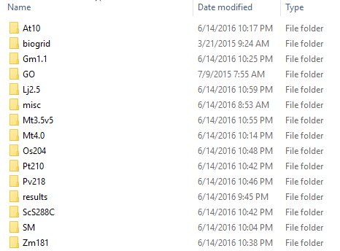

Figure 2.1. Example contents of data directory; “misc,” “biogrid,” and “GO” contain additional annotation metadata while “results” is auto-generated during later processing steps. The rest of the directories represent species.

Place all associated files for each assembly and version in their associated directories as exampled in Figure 2.2. Accepted file types and formats are:

* FASTA files for Assembly, Proteins, Transcripts, miRNA definitions, and gene sequences
* GFF3 files for genes and other features definitions also appended FASTA assembly
* TSV – InterProScan Results, BLAST+ Results
* .hmm.tbl – HMM Results
* Pathways – Must be the same format as PlantCyc
* .assoc – GAF 2.0 – Ontological Associations File
* .gtf / .fpkm_tracking – Cufflinks Expression

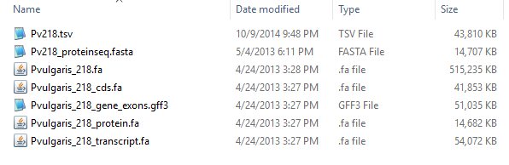

Figure 2.2. Contents of the Pv218 folder, showing the assembly FASTA file (Pvulgaris_218.fa), the CDS FASTA file (Pvulgaris_218_cds.fa), gene definition file (Pvulgaris_218_gene_exons.gff3), protein FASTA file (Pvulgaris_218_protein.fa), and the InterProScan results file (Pv218.tsv).

## Global Metadata Files

### Gene Ontology

GO/go.obo – Download the latest version of go.obo at <http://geneontology.org/page/download-ontology>

### ENZYME

misc/enzyme.dat – Download the latest version of enzyme.dat from <ftp://ftp.expasy.org/databases/enzyme>

### UNIPATHWAY

misc/unipathway.obo – Download the latest version of unipathway.obo from UniPathway’s website.

### Molecular Interactions

misc/mi.obo – Download the latest from <http://ontologies.berkeleybop.org/mi.obo>

## Pre-Configuration Processing

### Running InterProScan

<https://github.com/ebi-pf-team/interproscan/wiki/HowToRun>

We suggest the following options, as they allow ODG to make the maximum number of connections in the database.

* --goterms
* --iprlookup
* --pathways

If you alter any of the default output formats, you must be certain TSV is a selected output format, as this is the format ODG will read in.

**After InterProScan:** Copy the .tsv files to your data/<Genome Name>/ directories and re-start the configuration screen. Make sure to select the .tsv files for InterProScan for each genome you processed.

### Configuring the Database

To configure the database click on start-config.bat or run bash ./config.sh and point your web browser to <http://localhost:33333/> This will give you the initial configuration screen (unless you are editing a previous configuration). It may take a moment to load depending on the size of your dataset. Figures 2.3 and 2.4 show initial configuration parameters and an example of a specific genome configuration. Remember, each genome must be in a separate folder in the data directory, this translates into separate entries for the configuration program. Once everything is configured, you must save the configuration file.

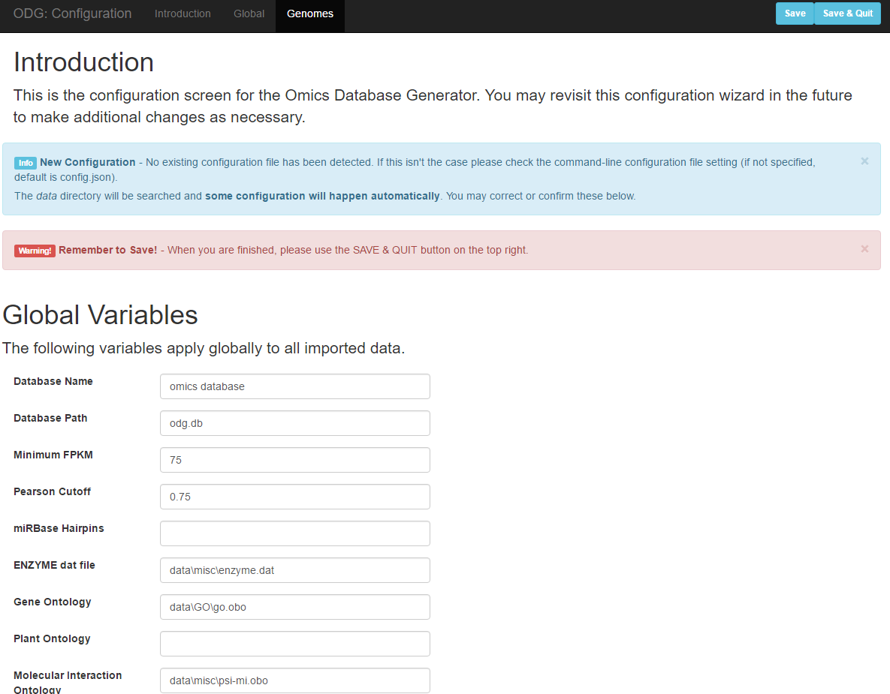

Figure 2.3. The initial configuration screen. Here you can set the database name, the path of the database, which is important if you are building multiple ODG instances, and set several other variables. If you are not using files, you may leave them blank. When possible, ODG’s configuration screen tries to identify and fill in certain files when they are present.

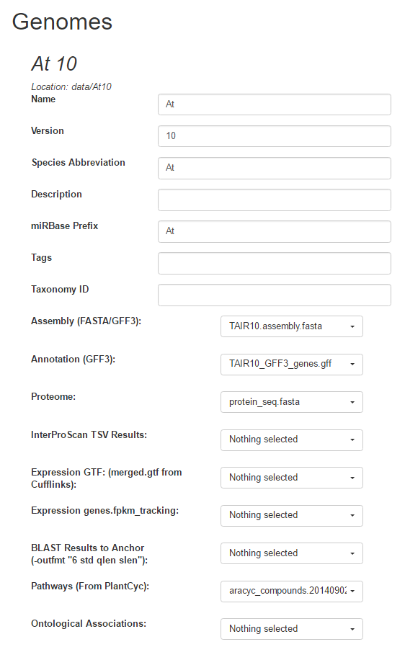

Figure 2.4. The initial screen for a genome configuration entry. When you are first editing a genome ODG will attempt to fill in as much data as possible and attempt to select the appropriate files.

## Post-Configuration Steps

### Generating BLAST+ Scripts

If you wish to run BLAST+ on a separate machine, such as a remote server, please copy everything in your ODG directory, including all subdirectories, to that machine. You can then execute “**create-blast-scripts.sh**” or “**create-blast-scripts.bat**” (when using a Windows machine). To then run the BLAST+ commands, you will execute “**run-blast-scripts.sh**” (or “**run-blast-scripts.bat**”). This process will take some additional time. Advanced users can examine other options by running ODG without any arguments.

Generating InterProScan Results

While the detailed instructions for running InterProScan locally is beyond the scope of this manual, it is relatively straight-forward. Please be aware InterProScan must be run on a UNIX machine, neither Windows nor Mac OS X will suffice.

**Please begin here:** <https://github.com/ebi-pf-team/interproscan/wiki/HowToDownload>

**Please Note:** Once you have downloaded InterProScan, you must also download the Panther Models. This is a very large file that you will want to keep between subsequent runs of InterProScan if at all possible.

# Generating the Database

Run “create-db.sh” or “create-db.bat” as necessary for your machine. This process can take a long time depending on the number of genomes and other data being connected in the database.

# Querying the Database

## Web-based Query Mode

To begin the web-based query server, simply run the command “query-server.sh” or “query-server.bat” as necessary for your machine. Then you may set your browser to <http://localhost:6789>

The query server can be terminated by switching to the window and hitting Ctrl-C.

## Command-line Query Mode

The following queries are built-in and may be used from the command line. An example would be ‘./odg.sh query-tassel –s “Species Name” –v “Version” tassel-output.txt’

Species name and version should always be provided and based on their entry in the original configuration. Input files should be tab-delimited unless otherwise specified. The “-o” option can be passed to alter the output file names.

### query-tassel

Input file is the –stats.txt file from TASSEL output. Command-line should be run such as:

‘./odg.sh query-tassel –s “Species Name” –v “version” chr1-stats.txt’

It is advisable to filter the TASSEL file to only the top hits, to avoid analyzing each individual SNP in the genome regardless of statistical significance.

### query-gene-list

Computed aggregate stats for a gene list, given in the format of gene_id followed by allele frequency.

‘./odg.sh query-gene-list –s “Species Name” –v “version” gene_list.tsv’

### annotate-gene-list

Annotate a gene list with further information from the database, the input file should be a file with the first column being gene-ids.

‘./odg.sh annotate-gene-list –s “Species Name” –v “version” gene_list.tsv’

### coexpression-network

Generates a basic co-expresison network based on Pearson-correlation coefficients. Input file should be a list of gene names. For example this could be done given a list of genes that are statistically significant in a GWAS analysis. Output files include a TSV and a GDF file, the latter which can be viewed using Gephi software or other GDF-supporting graph interfaces.

‘./odg.sh coexpression-network –s “Species Name” –v “version” gene_list.tsv’

### get-biological-processes

Given a gene list, identifies GO terms labelled as biological process and outputs a list.

‘./odg.sh biological-processes –s “Species Name” –v “version” gene_list.tsv’

### get-biological-processes-all-genes

Identifies all genes with a biological process GO-term for a species. Useful for generating a null distribution for biological process tests for a given gene list.

‘./odg.sh biological-processes –s “Species Name” –v “version”’

# Internal Data Structure

## Nodes

In a graph database a node is a piece of data that serves the same function as a 'row' in a spreadsheet or SQL table. A node is connected by relationships, which may be incoming, outgoing, or non-directional. Nodes will typically have properties, which are analagous to a column entry of a row in a spreadsheet. All nodes also have one or more “type” which tells you what type of data the node contains, and which types of relationships are possible. For example a “gene” node may be a “parent” of an mRNA node, which is itself a parent of an “exon” node .

**Each node has a unique, internally generated “id” number. These ID numbers are useful to refer to nodes in scripts and multiple-query analyses, however they are guaranteed to change if the database is ever regenerated, even if no input files change.**

## Relationships

Nodes are connected to each other by relationships, which have no direct analogy in spreadsheets. Relationships themselves may have properties and a type, and all relationships have a start and an end, which are both nodes. A node may have a relationship to itself, but this is not common in the output database of this project.

## Examining the Internal Data Structure

The best way to examine the internal database, not through the ODG query lens, is to download the database host software from <https://neo4j.com/>

By downloading this, it is possible to open the database directly in Neo4J’s web-service query, from which you can see all node labels and relationship types, and explore them. This web-based interface allows a graphical interpretation of the networks provided. Further queries can be written directly in Neo4J’s query-language, CYPHER, with more information available here: <https://neo4j.com/developer/cypher-query-language/>

This interface is useful for building queries, and testing concepts and ideas. However, for any complicated analyses, the best approach is to use a programming or scripting language and hook into the database. This will often require the host software and is beyond the scope of this guide.

## Language Hooks

Language hooks allow you to directly connect from a programming language such as R or python to the output database of Neo4J and write advanced scripts and analyses. These are intended for advanced users only, and bypass much of ODG (except database generation) to work directly with the database. Please be aware, if you are interested in importing additional or new data, you should contact me as there is much functionality for “generic” database inputs.

### R-language

<https://neo4j.com/developer/r/>

### Python

<https://neo4j.com/developer/python/>

### Java

<https://neo4j.com/developer/java/>

### Perl

<https://neo4j.com/developer/perl/>

### Additional Language Hooks

Additional languages can often be found on the internet, and some are available here:

<https://neo4j.com/developer/language-guides/>